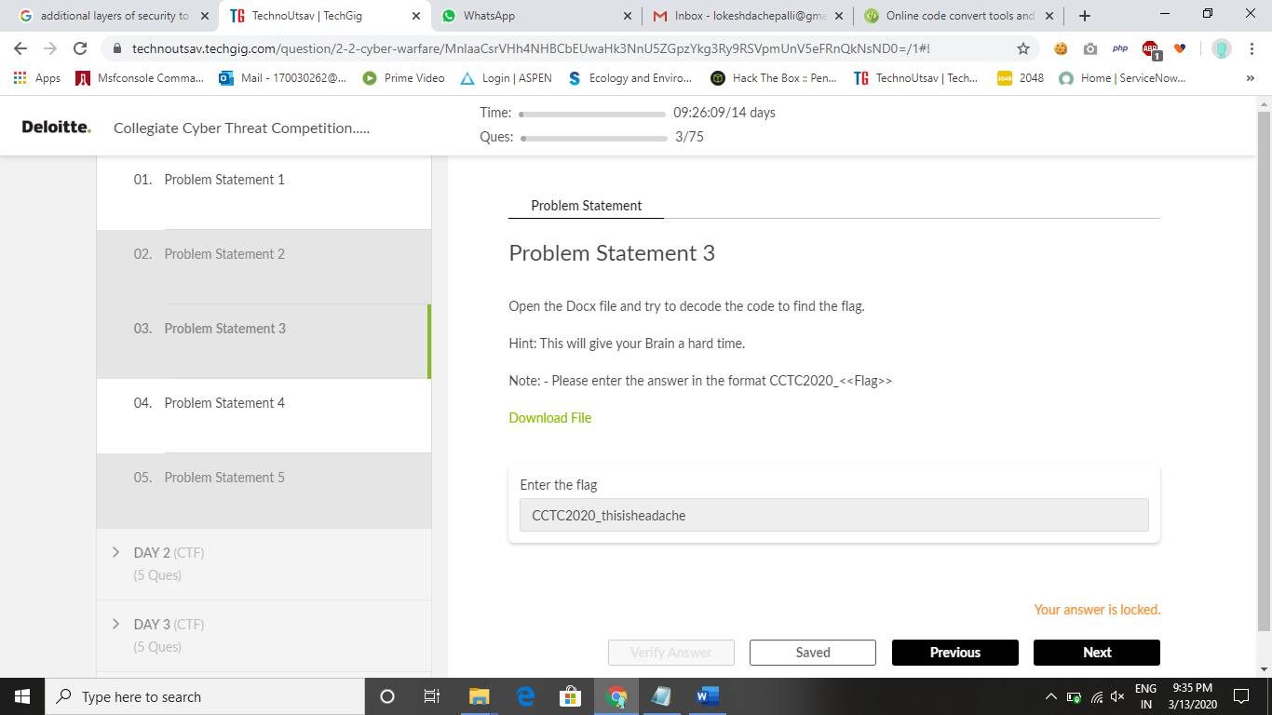

Download File (https://techgig.com/files/contest_upload_files/Brain_Damage.zip)

Solution:

They says open the document and decode the flag. So,I directly opened the document .

When I see that document I was fully confused how to do it …!

So I thought and take some part of encoded text and have searched in google.

The brilliant gives me the correct one it says the encoded text is of Brainfuck encoded form.

So I have check for online compilers I got one website it helped me a lot <https://fatiherikli.github.io/brainfuck-visualizer/>

So I have copied all the content in the source code and had run the compiler that gives me a statement

“This might have obviously given you a headache, I hope you know how to proceed with this one. This will give you 2 times the headache you got earlier. Grab some tea tea tea tea tea tea for - **ZEdocGMybHphR1ZoWkdGamFHVT0=**”

I get to know that end of the sentence is of base64 encoded form so I decoded it using the base64 decoder . even though I didn’t get the flag.The decoded form gives an another base64 value

I decoded it then I got the flag value.

Submit the flag in the form:CCTC2020_<<FLAG>>

Happy Hacking…!